Kafka

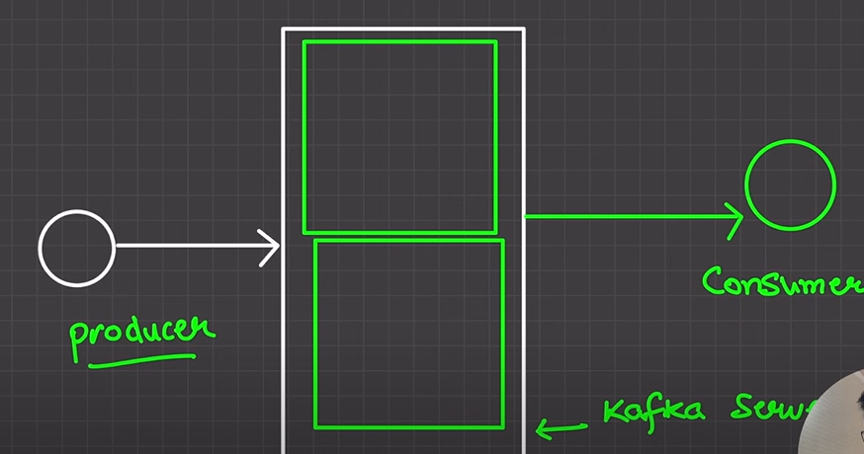

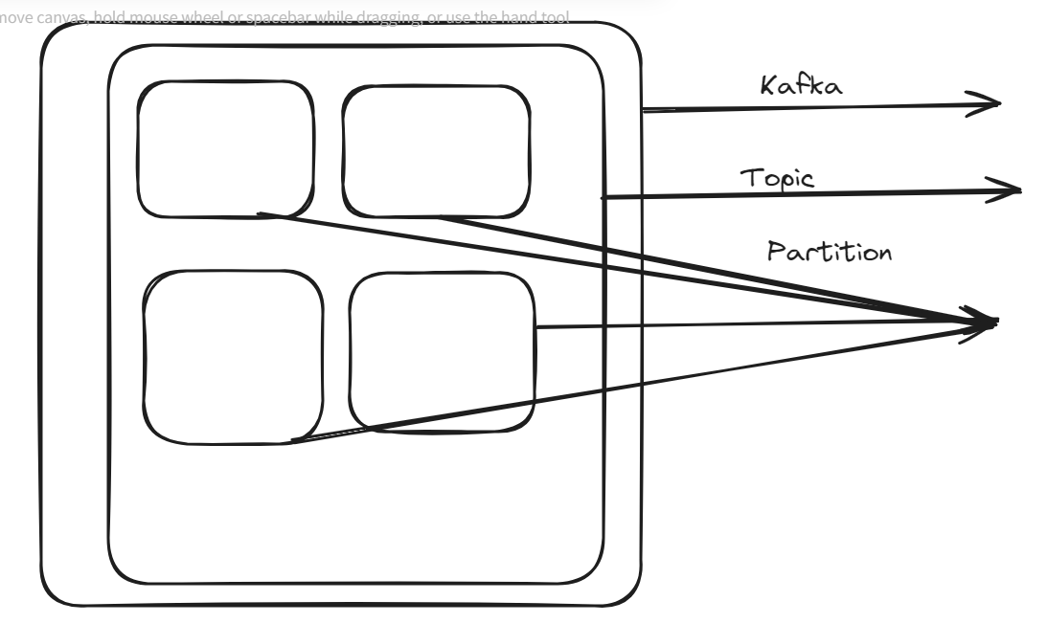

In the Green Box is known as topic.

What is topic: Topic is nothing but logical **Partitioning** of the messaging.

Example: let say that WhatsApp group and we have different types of groups. We can say that or assume that family group, Office group etc.

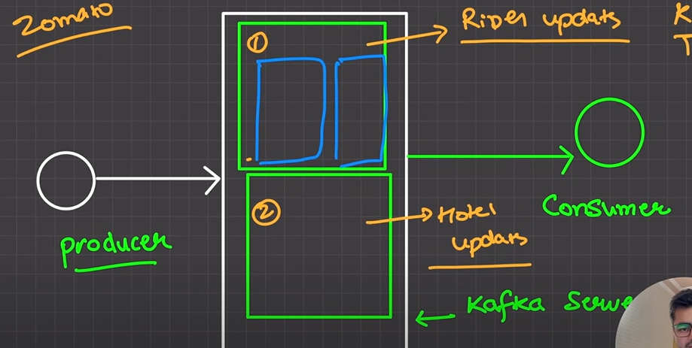

In the green box as you can see there are two blue box are there that is known as **Partition**.

There are can more than one **Partition** in a topic. Its depend upon you and your application**.**

**Now we have Kafka, topic, Partition or queue. What does mean it.**

**It means, let’s assume that we have Kafka. Inside Kafka we have topic. And topic has partition or queue.**

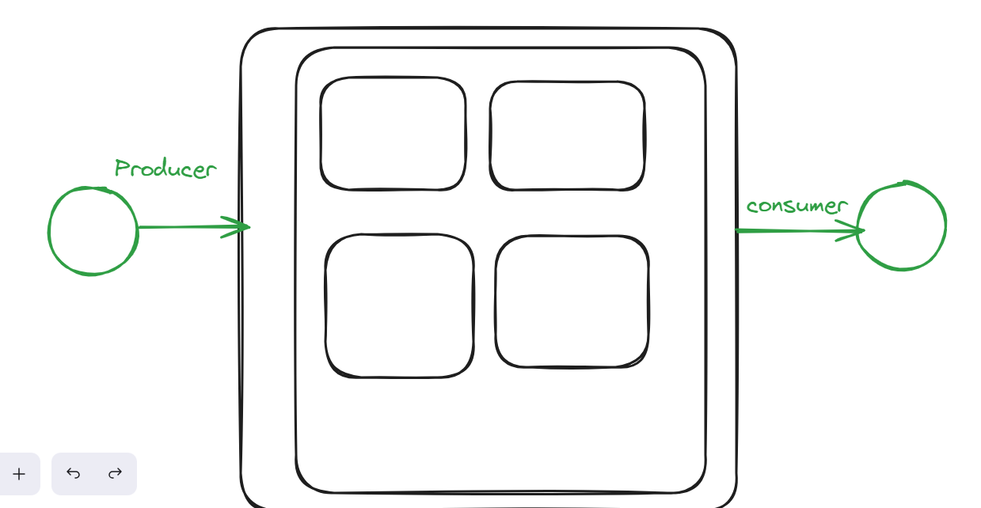

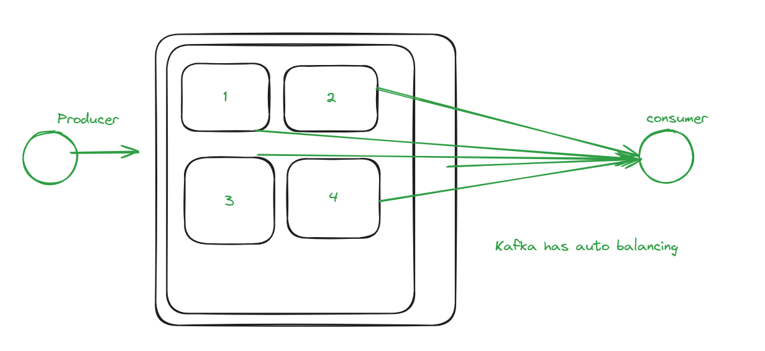

Let’s assume that we have one more consumer so at that time how it will be balancing.

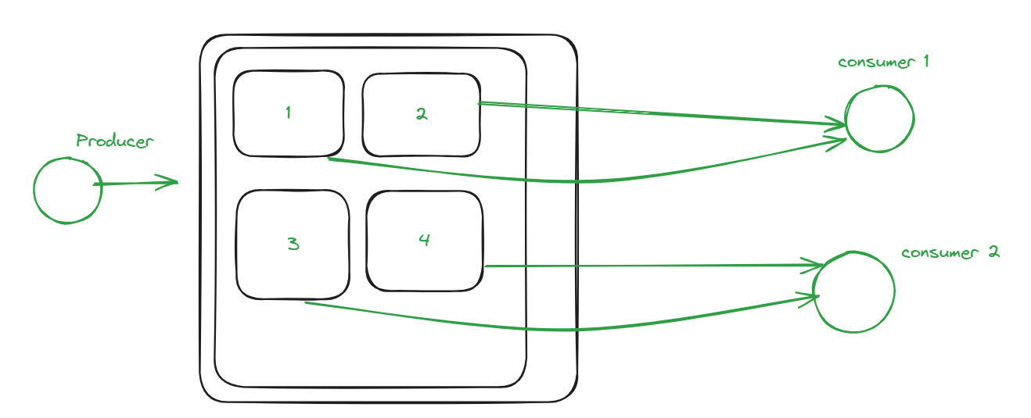

Let’s assume that we have one more consumer so at that time how it will be balancing.

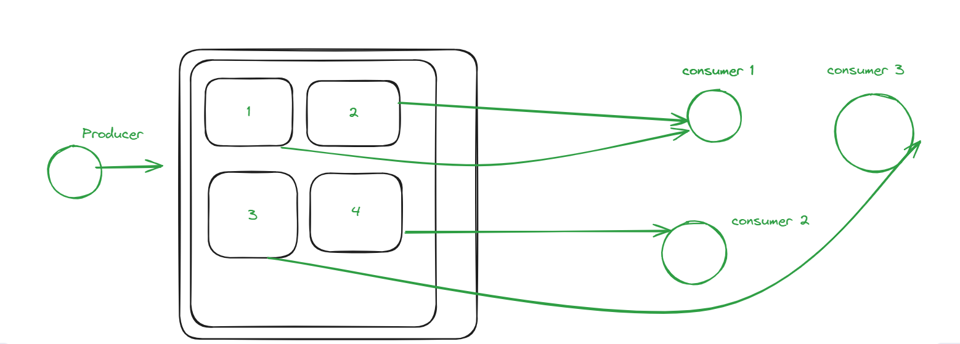

Let’s assume that we have one more consumer so at that time how it will be balancing.

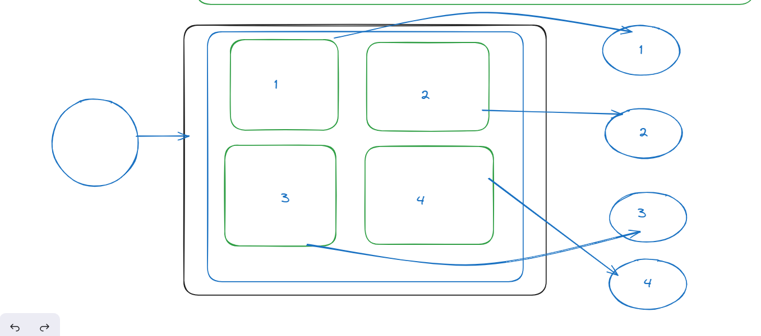

Let’s assume that we have one more consumer so at that time how it will be balancing.

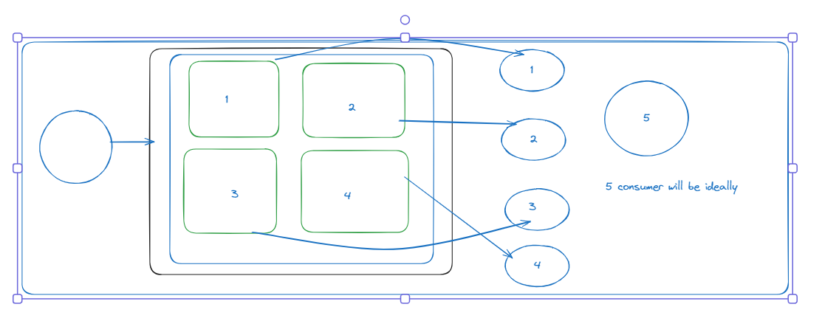

1 consumer can consume multiple Partition.

1 partition can consume 1 consumer.

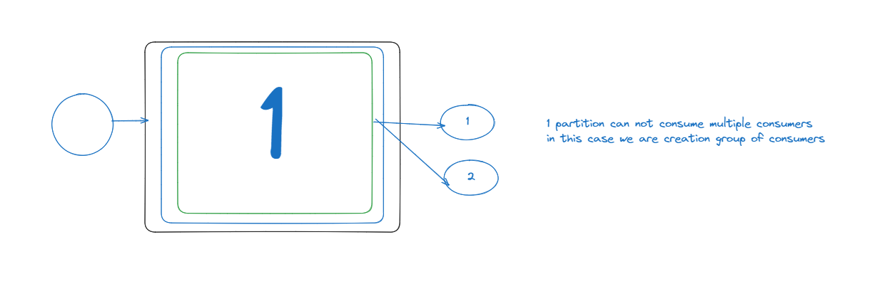

Consumer Groups

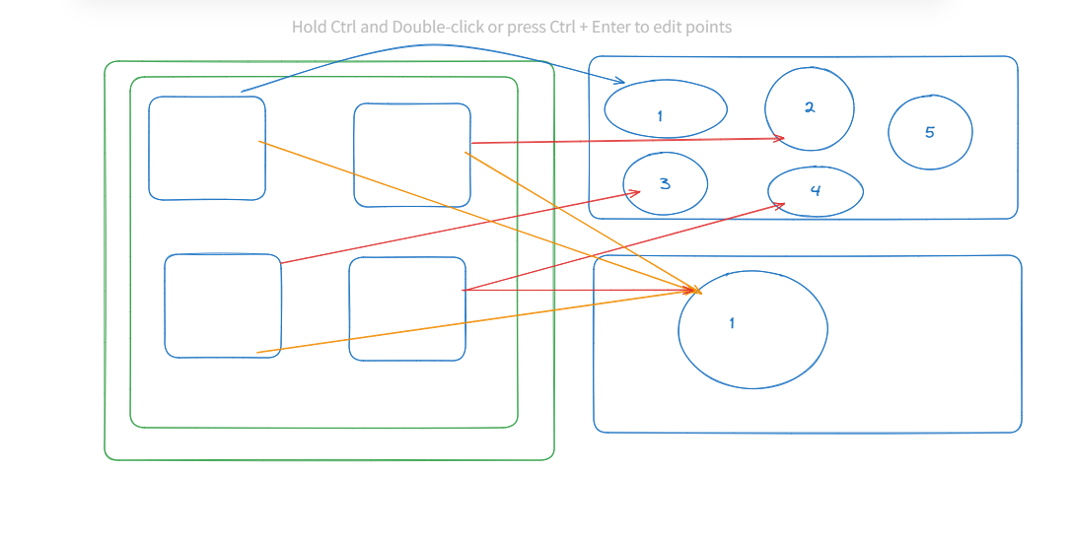

Why it is complicated and what is benefits for it.

Now, the concept is coming to picture hear.

Queue and Pub/sub

Queue:

Pub: Publisher

Sub: subscriber

Queue:

One Publisher and one consumer.

Pub/sub:

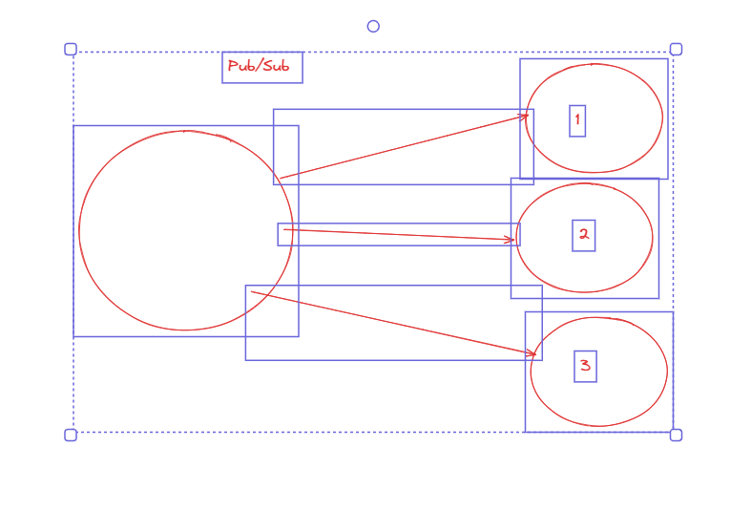

Example: Best is YouTube

One Producer has more than one subscriber.